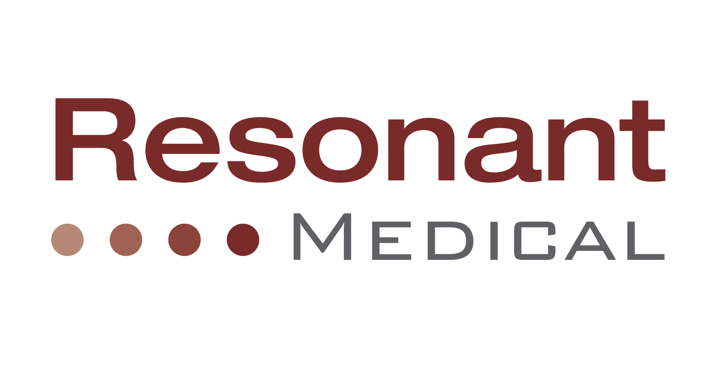

Clinical specialist

The Company
Resonant Medical researches, develops and markets 3D ultrasound image-guided adaptive radiotherapy products. Our goal is to enable fundamental improvements to radiation oncology treatment planning, verification and delivery. Resonant's RestituTM platform features significant advances in ultrasound hardware and software imaging to fully harness the advantages of 3D ultrasound for radiation therapy image guidance. The first offering of the RestituTM platform is a tumor position verification and patient alignment system, and a wide number of additional products and technologies are currently under development.

Position Description
The specialist will be exposed to a wide variety of clinical technologies and systems at various cancer centers, and will ensure complete integration of Resonant’s image-guidance platform across these diverse clinical and research environments. The Clinical Specialist will be a key contributor to the success of this rapidly growing company by assuming three important responsibilities:
- Clinical support: Interface with customer and research partners by providing product training, configuration, and support. Excellence will be attained by providing attentive, high-quality assistance and innovative solutions to medical physicists and radiation oncologists across the continent.
- Clinical research management: Establish and coordinate clinical research projects with a wide number of leading edge cancer centers and universities in North America and Europe. Act as liaison between research teams in academia and Resonant’s own R&D department and internal research initiatives.
- Technology development: Contribute to the definition and design of the next generation of image-guidance products, and towards the evolution and development of the company’s core technologies.

Responsibilities
- Integrate Resonant’s technology to the cancer centers and research partners’ systems, workflow and protocols
- Provide front line support of highly advanced image-guidance products and technology in both research and clinical environments
- Engage in continuous improvement of research, clinical and QA protocols
- Contribute to definition of image-guidance product requirements, new functionality and development priorities
- Publish internal R&D research results. Assist in the publication of external research partners results.
- Occasionally conduct presentations. Participate to conferences and tradeshows

Qualifications
- Master or preferably Ph.D. and clinical experience as Medical Physicist
- Interest or experience in information technology related fields
- Excellent oral and written communication skills
- Deep commitment to customer satisfaction and successful clinical management.
- High interested in technology and technical advances
- Driven, self started individual motivated to work and prosper in a high-growth, high-technology medical company in the Radiation Oncology sector.
- Willing and able to travel occasionally

Contact
Please send your resume to Luc Sirois
Luc.sirois@resonantmedical.com
514-386-1272

