

PHYSICISTS
BC Cancer Agency

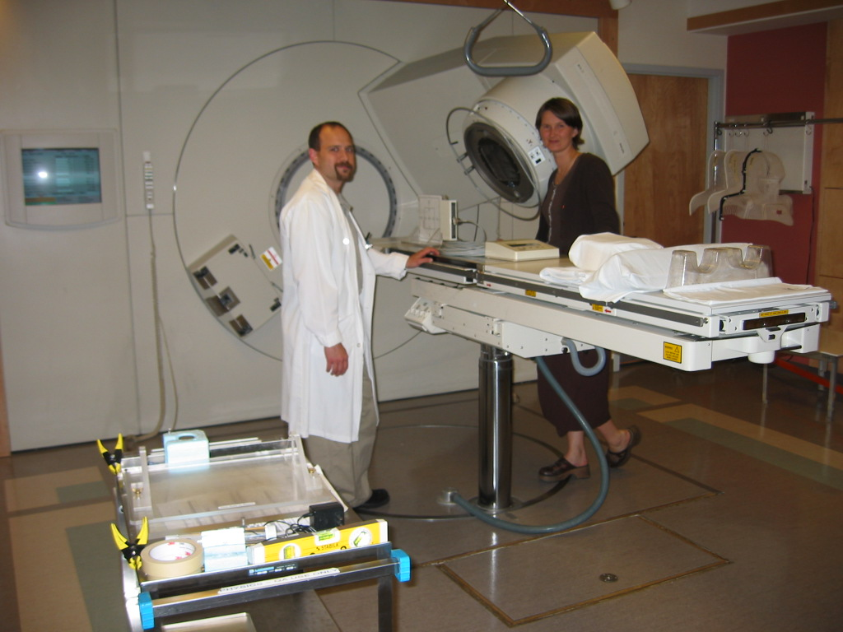
The British Columbia Cancer Agency (BCCA) is currently accepting applications for Medical Physicists specializing in radiation therapy physics. BCCA is a multi-disciplinary diagnostic, treatment and research organization dedicated to cancer care of the highest quality. At present BCCA operates four cancer centers located in Vancouver, Victoria, Surrey, and Kelowna. A fifth centre will be opening in the spring of 2008 in Abbotsford. Currently one Senior Physicist position is available at the Vancouver centre and several new positions have been created for physicists who will re-locate to the Abbotsford centre in 2007.

Successful candidates will be expected to participate in clinical service including treatment planning, technique development, selecting, acceptance testing, commissioning, calibrating and quality assurance on all radiotherapy equipment. Participation in clinical research and teaching are also expected.

Candidates should hold a Ph.D. or M.Sc. degree in Medical Physics. A minimum of two years’ experience in Radiation Therapy Physics is required and preference will be given to applicants with membership in the CCPM. Exceptional candidates not meeting these requirements may be considered.

In accordance with Canadian Immigration requirements, priority will be given to Canadian citizens and permanent residents of Canada.
Qualified applicants should submit a resume with the names of three referees to:
Cheryl Duzenli, Ph.D., FCCPM
Professional Practice Leader for Medical Physics
Vancouver and Fraser Valley Centres
BC Cancer Agency
600 West 10th Avenue
Vancouver, BC V5Z 4E6

Attention: Melanie Cox
Administrative Assistant
Medical Physics
An agency of the Provincial Health Services Authority

